ASSENT FORM
Green text needs to be adjusted to your project
INSERT PROJECT TITLE
- I AM DOING MY SCHOOL PROJECT AND WANT TO INVOLVE YOU.
- I AM ASKING OTHER TRAINEES TO HELP ME OUT TOO.
- I WANT TO KNOW
- IF YOU ARE HAPPY TO HELP OUT WITH MY SCHOOL WORK;
- IF YOU CAN UNDERSTAND WHAT I AM ASKING YOU.
- I WILL GIVE YOU A TABLET TO USE AND ASK YOU TO TAKE SOME PHOTOS. (adjust according to what you project is about)

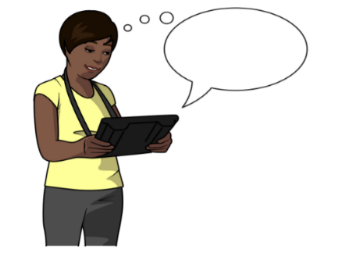
(Illustrations needs to be adjusted to your project)

- PLEASE TAKE PHOTOS OF ANYTHING THAT MEANS A LOT TO YOU WHEN YOU ARE AT (xxxx).

- I WILL COME WITH YOU JUST IN CASE YOU NEED ANY HELP TO MAKE SURE THE TABLET IS WORKING OR IF YOU WANT TO ASK ME ANYTHING.

- I REALLY WANT TO KNOW WHAT YOU THINK OF YOUR TIME AT (xxxx).

- THEN WE WILL COME BACK AND CHAT ABOUT THE PHOTOS YOU TOOK, CHOOSE YOUR FAVOURITE 2.

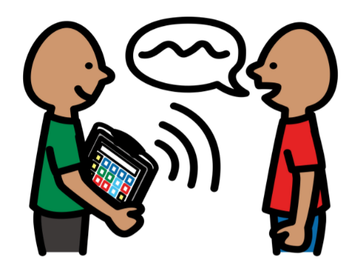

- I WANT YOU TO KNOW THERE IS NO RIGHT OR WRONG ANSWERS. EVERYTHING YOU SAY IS IMPORTANT TO ME.

- AFTER OUR CHAT WE MIGHT GET OTHER HELPERS TO JOIN. WE CAN THEN SHARE THE PHOTOS WE HAVE TAKEN AND TALK ABOUT THEM ALL TOGETHER.

- WHEN I DO MY SCHOOL PAPER, I WANT TO INCLUDE THE THINGS WE HAVE TALKED ABOUT.
- I WILL HAVE LOTS OF ANSWERS FROM YOU AND OTHER TRAINEES WHO WERE HAPPY TO JOIN MY SCHOOL PROJECT.

- I WILL USE MY MOBILE TO RECORD OUR CONVERSATIONS SO THAT I DON’T FORGET THE THINGS YOU TELL ME.

- YOU CAN CHANGE YOUR MIND ABOUT JOINING IN WITH THE RESEARCH AT ANYTIME.

- WHEN I DO THE PAPERWORK, I WILL MAKE SURE YOUR NAME AND OTHER PRIVATE THINGS YOU TELL ME, IS NOT INCLUDED. NOBODY WILL KNOW WHAT YOU HAVE SAID APART FROM ME AND YOU.

- PLEASE TELL ME IF YOU WANT TO SEE, CHANGE OR DELETE THE ANSWERS YOU GAVE AFTER WE HAVE FINISHED CHATTING ABOUT YOUR SELECTED PHOTOS.

- I WILL MAKE YOU A LITTLE SCRAPBOOK AT THE END OF MY PROJECT SO THAT THE PHOTOS YOU TOOK ARE PRINTED TO TAKE HOME AND SHOW OTHERS.

- IF YOU WANT TO HAVE THE FINAL RESULTS OF MY SCHOOL WORK, PLEASE TELL ME AND I WILL INCLUDE THIS IN YOUR SCRAPBOOK.

- WHEN I HAVE FINISHED WITH MY PAPER, I WILL DELETE ALL THE RECORDINGS I HAVE ON MY MOBILE.

- SOME THINGS YOU SAY MIGHT HELP TO IMPROVE YOUR EXPERIENCE AT (XXXX).

- SO…
- YOU TAKE PHOTOS OF WHAT’S IMPORTANT TO YOU AT (XXXX).
- YOU TALK ABOUT THESE THINGS WITH ME AND SHARE WITH OTHER TRAINEES WHO ARE HELPING IN THE PROJECT TOO.
- YOU GET THE PHOTOS IN A SCRAPBOOK AS A THANKS FROM ME TO YOU.

- AFTER HEARING THIS, ARE YOU HAPPY TO TAKE PART IN MY PROJECT?
- CAN I CHECK YOU HAVE UNDERSTOOD WHAT MY PROJECT IS ABOUT? AND WHAT YOU WILL BE DOING TO HELP ME IF YOU SAY YES?

- IF YOU WANT TO ASK ME ANYTHING ABOUT THE PROJECT, YOU CAN CONTACT ME DIRECTLY ON (XXXXXXXXX) OR SPEAK TO ME NEXT TIME YOU SEE ME.

- I WILL GIVE YOU A LETTER OF AGREEMENT WHICH EXPLAINS THE THINGS WE TALKED ABOUT TODAY. I WOULD LIKE IF YOU CAN TAKE THIS HOME AND SHOW IT TO YOUR PARENTS/CARERS. COULD YOU ASK THEM TO SIGN THE FORM AND RETURN TO ME NEXT TIME I SEE YOU?
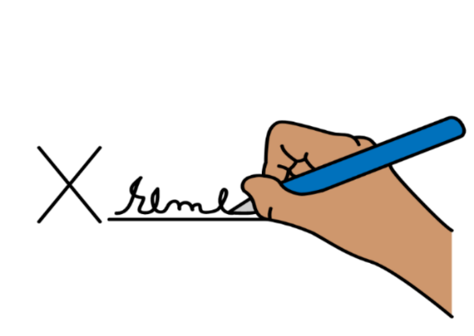
- IF YOU ARE HAPPY TO PARTICIPATE IN MY SCHOOL PROJECT, COULD YOU SIGN THIS PAPER PLEASE?

PRINT PARTICIPANT’S NAME __________________________________

SIGNATURE OF PARTICIPANT __________________________________

SIGNATURE OF RESEARCHER __________________________________

DATE _____________________________________________________

