How to connect ORCID to your NVA profile
The Norwegian national science archive (NVA) imports articles from external sources to reduce the number of articles researchers have to register manually. Connecting your NVA user profile to your ORCID ID helps NVA to import your articles faster and with better data quality.

You need to be
- Logged in to NVA
Step-by-step
See next page for more detailed description.
- Log in using
  - Feide – for most HEI institutions
  - HelseID [POC] – for hospitals
  - ID-porten – for research institutes and HEI institutions without Feide
- Click on “My page” in the top right corner of the header.
- At the bottom of the left menu, click on “User profile”.
- At the bottom of your user profile, click on “Connect/Get ORCID”.
- In the pop-up window, click again on “Connect/Get ORCID”.
- Log in to your ORCID profile or register to get an ORCID ID.
- When you receive a request from Sikt to get access to your ORCID, click “Accept connection”.
Your NVA user and ORCID profile are now connected!

Picture guide
In the top right corner of the page, click the button “My page”:
At the bottom of the left menu click “User profile”:
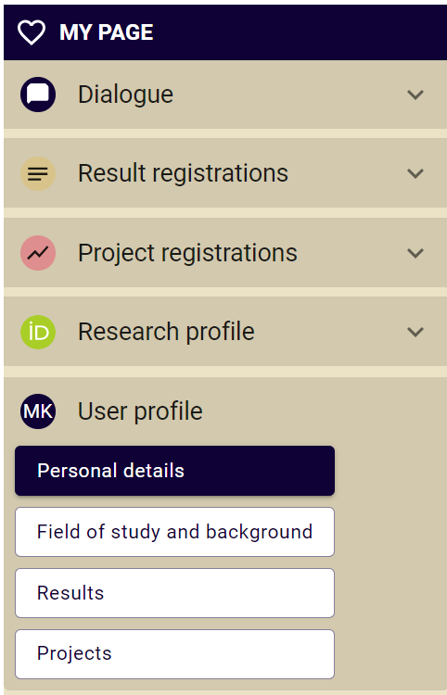

At the bottom of the page called personal details, click the button “Connect to/Get ORCID ID”:
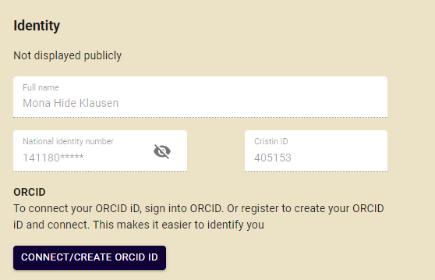
You’ll get a pop-up with more information about what ORCID is and what it can be used for. Click again on “Connect/Create ORCID ID”:
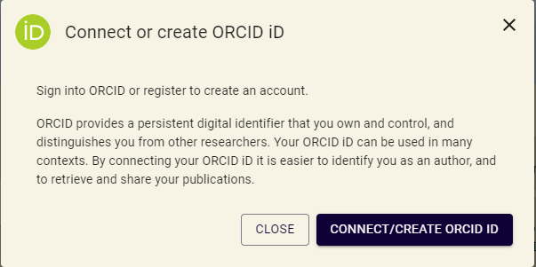

You will be redirected to ORCID’s website, where you can either log in to an existing profile or register a new profile.
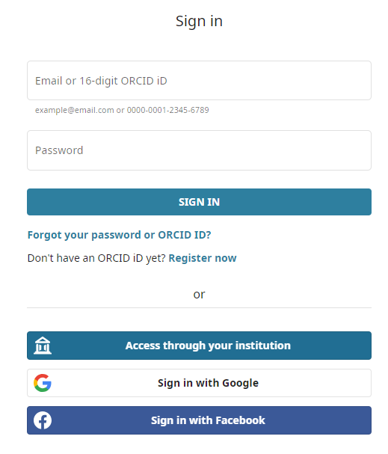
To create a new ORCID profile, fill out the information in the forms.
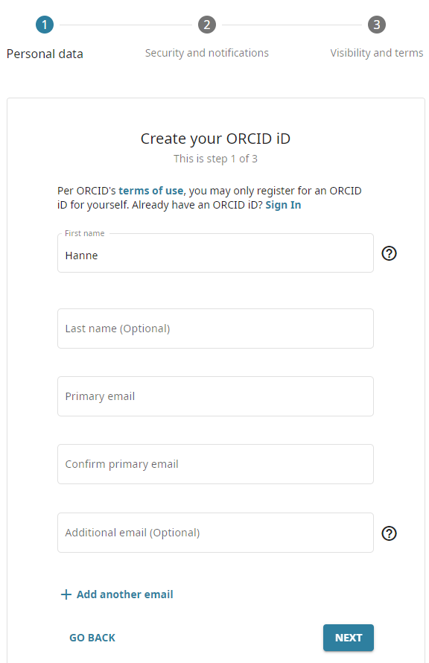

When you have logged in, or registered a profile, you’ll receive a notification saying that Sikt requests access to your profile. Click the button “Authorize access” to approve the connection between your NVA user and ORCID profile.
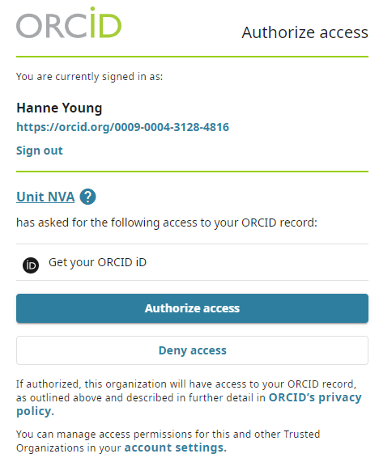
When returning to your profile in NVA, your ORCID should now be registered at the bottom of the page.
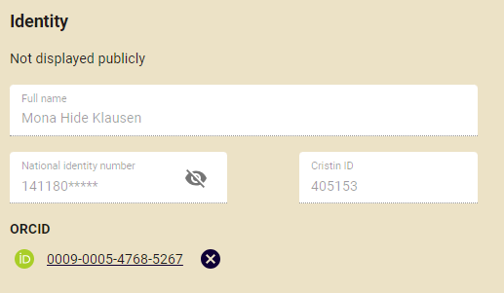
Your NVA profile and ORCID profile are now connected.

