Register project i NVA

You need to be
- Logged in
- Have a registered employment at a customer institution in NVA to gain access to registration (please contact the curator if you don’t have the registration button).

Content
Picture guide 2
How to find the registration form 2
1) When registering a result 2
2) Via “My page” > “Project registrations” 3
Register information about the project 3
Link results to the projekt 5

Picture guide
There are two ways to register a project in NVA:
- While you register a result. This creates an automatic link between the result you are registering and the project you register.
- Under “My page” and “Project registration” (left margin). Here you need to register the project first, before you can add results.

How to find the registration form

When registering a result
Click the button “New result” in the main header:
On the first registration page, “Description”, you can link the result you are currently registering to a project that has already been registered in NVA. Search for the project in the search bare titled “Project ???”.
If the project hasn’t been registered already, you can register it while registering the result. Click the button “+ New project”, to the right of the search field where you search for existing projects, to open the project registration form.

Via “My page” > “Project registrations”
Click the button called “My page”, to the right of the header menu.
In the left margin, click on “Project registrations” and then the button “+New project” to open the project registration form.
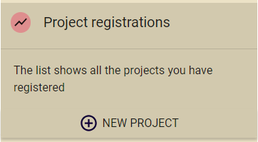

Register information about the project
In the registration form, you may choose between searching for a project that is registered with the Research Council of Norway (NFR) or open an empty registration form.
If the project is funded by the Research council of Norway, NVA may retrieve some of the information from their project bank and automatically preregister it in NVA. Search for either the project name or the name of the project leader, as it is registered in the project bank, in the search field to retrieve the information.
Remember to check the information that is automatically preregistered and add other, relevant information about the project.

To open an empty registration form, click on the button “Empty registration”, beneath the search field, and then the “Start” button at the bottom right corner.
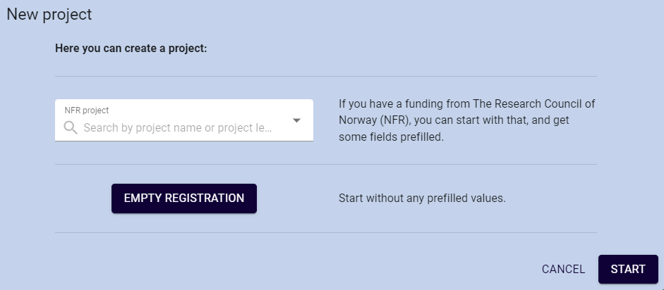
You will now see the registration form. Mandatory information is marked with a red star * (asterisk).
Enter title, coordinating institution, start and end date, add the project manager and participants, and information about funding (if relevant).
The first person you add to the project will automatically be assigned the role of project manager, and the next people you add become project participants.
Note that the project manager and participants must be registered users in NVA. Administrator at your or their institution may register them manually, if they themselves are unable to log in to create a user profile.
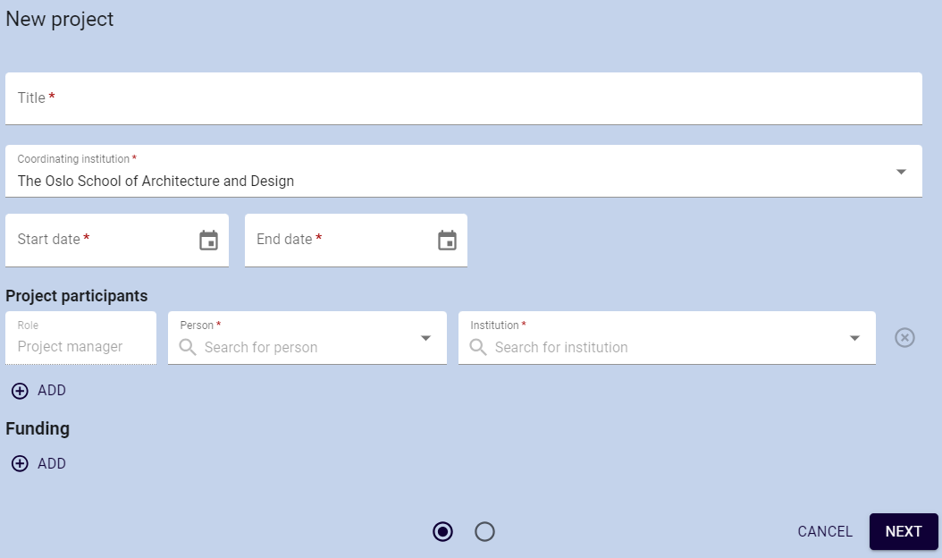
If you wish, you may add more descriptive information about the project, such as project category, keywords, scientific abstract (Norwegian and English), popular science summary (Norwegian and English).
You may also link the project to other projects in NVA. Search for the other projects in the bottom search field named “Related projects” to link them.
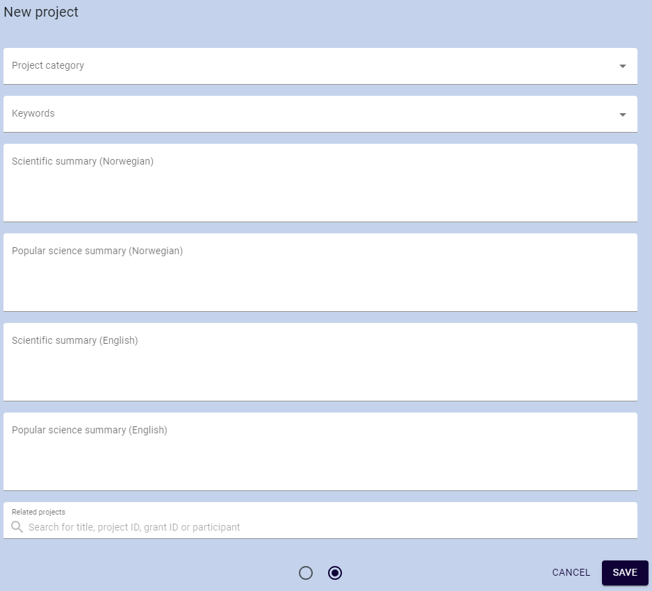
Click the “Save» button in the bottom right corner of the registration form to create the project.

Link results to the project
You can link results to the project to better showcase your research.
Go to the result you wish to add and click the edit pencil. In the first page of the registration form, named “Description”, search for and select the project to link the two together. Do the same for all results you wish to link to the project.

