Register results in NVA

You need to be
- Logged in to NVA
- Have a registered employment at a customer institution in NVA to gain access to registration (contact the curator if you don’t have the registration button)

Content
Picture guide 2
Chose registration form 2
Check automatically registered information 3
Register result: "Start in empty registration form" 3
Description 3
Link to project 4
Funding 4
Category 5
Artistic result 7
Contributors 8
Select identified user profiles 8
Files and licences 10
Rights retention strategy (RRS) 10
License/Terms of use 11
Embargo 12
If your institution does not have an RRS, but you must follow Plan S 13
Publish metadata 13
Help with registration 14

Picture guide
Click the button «New result” in the header menu:


Chose registration form
There are three ways to register a result:
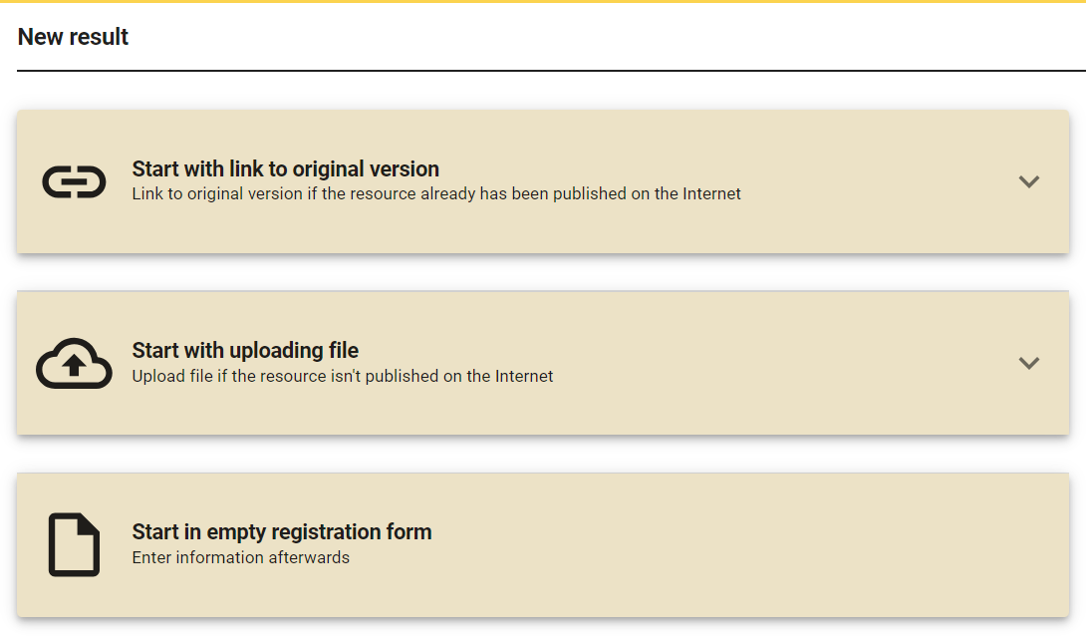
- “Start with link to original version”: paste the DOI link to the publication. NVA automatically retrieves and preregisters available information. How much information NVA can retrieve, depends on the publishers’ systems.
- «Start with uploading file»: uploads the full-text version of the publication. Note: NVA doesn’t retrieve information from the file.
- «Start in empty registration form»: you enter the information yourself. This guide is based on this method.

Check automatically registered information
Remember to check the information that is automatically preregistered in method 1. Contributors from NVA-institutions may be registered as "free text names" without an ID. You need to change that name to their identified profile, to enable NVA to link the result to their researcher profile. This is especially important for academic publications that are included in the reporting to the Norwegian Science Index (NVI).

Register result: "Start in empty registration form"
Registration is divided into four pages:
- Description
- Resource type
- Contributors
- Files and license
To navigate between the different pages of the registration, click on the titles at the top of the registration form.
You can also click on the blue arrows at the bottom left and right corners of the registration form to browse through the different pages.
Click the Save button at the bottom right of the registration form to save a draft. You can continue the registration at any time by going to "My page" > “Result registrations” and selecting the relevant draft from the list.

Description
Here you enter descriptive information (metadata) about the result, such as
- Title
- Abstract
- Description of content, if relevant.
  - For example, for artistic works where a text summary is not as relevant.
- Keywords
  - This makes the article more searchable in NVA. Note: errors by publishers often result in subject area/field of study being preregistered as keywords in NVA.
- HRCS activities and - categories.
  - Only relevant for health research.
- Date published.
  - To only register year, tick the box “year only” to the right of the date field
- Primary language for content.
Information that is required to make the registration publicly available, is marked with a red star* (asterisk).

Link to project
You can link the result to a project that is registered in NVA, or register the project while you register the result. Linking results to a project increases visibility of your research in NVA. The result directs the reader to the project, which in turn showcases other results. Similarly, information about funding makes your research visible in searches for funders, such as the Research Council of Norway (NFR) or the EU.

Funding
- Funding = information about the "money bag" that has been granted to carry out the project.
- Funder = the name of those who granted the money. This could be public and private institutions, private companies, funds and legacies, EU framework programs, or government bodies, e.g. The Research Council of Norway.
- Grant name = the name of the project as it is registered in the funder’s system, for example The Research Council's Project bank.
- Grant ID = the ID the funder has given the grant in their system. In The Research Council's Project bank, called "project number".
When you report to The Research Council of Norway (NFR), the Project bank automatically retrieves publications from NVA that have NFR's project number. You register the number in the "Grant ID" field in NVA.
You do not need to register funding information on each individual result that you want to include in the report. You only need to register funding information on the project, and the results you link to the project in NVA will "inherit" the funding information. However, if a specific result has more funders than the project itself, you may add these funders to only the result.

Category
NVA has 61 result categories in 11 main categories (left margin). Results in categories titled “academic”, and marked by a “flower”, may be included in the NSI report (Norwegian Science Index; no: NVI). Research institutions and health trusts receive part of their funding based on the number and quality of academic publications in the previous year.
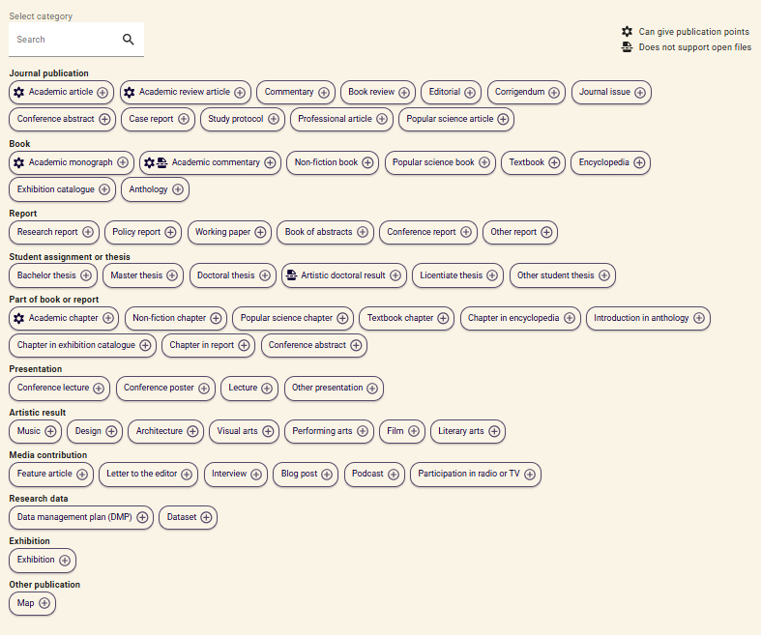
When category is selected, you will be asked to enter details about the publication or performance. The type of information you’re asked for, depends on the category you have chosen.

Artistic result
The categories under artistic result are:
- Book Publication
  - Exhibition Catalogue
- Part of a Book or Report
  - Chapter in Exhibition Catalogue
- Artistic Result
  - Music
  - Design
  - Architecture
  - Visual Art
  - Performing Arts
  - Film
  - Literary Art
- Exhibition
  - Exhibition Catalogue

When you have selected a category, choose the type of work and register information about its publication.
What type of work and the publication options that are available in the registration form, depends on the artistic result category you have selected. For example, a concert is only available for musical categories, and cinema screening is only available for film. For architecture, you also have the option to register awards.

Contributors
When you have selected the correct category, you need to add everyone who has contributed to the result.
Click the button “Add contributor”.
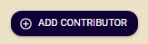
This opens a window where you may easily add yourself on the publication by clicking the button “Add me as contributor”. Add other people by searching for their names and chose the right person from the dropdown list. If you cannot find the right person, click the button “Contributor not found” to enter their names manually as an unidentified person without a person ID.
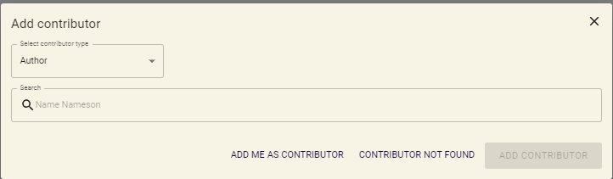

Select identified user profiles
When you search for a name, you get a dropdown list with similar names. Names with a registered affiliation to a Norwegian institution, are identified with a unique person ID. NVA needs this ID to be able to link the result to their researcher profile. In the NVI reporting, it is mandatory for authors who credit reporting institutions to be identified.
Unidentified names may have a yellow “warning sign” by their name, prompting you to search for an identified profile. Click on the button “Identify contributor” to open the search.
Select the person you wish to add. By checking the circle in front of their name you add all their affiliations. You may remove affiliations manually afterwards.
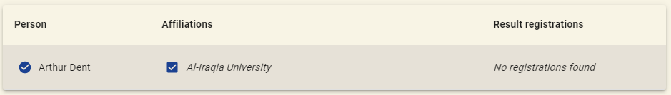
When you have selected a name, all circles in front of selectable information becomes blue check marks, and the button “Add contributor” turns blue and clickable.
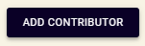
The person you have chosen, appear in the list of contributors. Once you have added all the contributors, you can change their order or their role, mark who is the corresponding author (check box), add or remove institutional affiliations, or remove the person from the list.
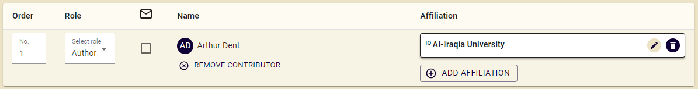

You may add contributors with different types of roles, not just authors. E.g.
- Contact person
- Rights holder
- Other
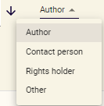
Available roles depend on the category you selected on the previous page.

Files and licences
To comply with the requirements of Plan S for open access to research results, you must upload a full-text version of your article. Which version of the article you can upload (accepted or the publishers’ published version) depends on the publisher agreement you have signed and your institution's rights retention strategy (RRS).

Rights retention strategy (RRS)
Some institutions have a policy called Rights retention strategy (RRS) where they reserve the right to publish the accepted version of an article in repositories (like NVA), regardless of the agreement between the author and the publisher. Check with your institution for the guidelines that apply to you. You may find information about the RRS if you click on the button in the main header with your institution’s acronym and then “Publishing strategy”.
Different institutions may have different RRSs. If you have multiple affiliations, make sure you follow the RRS of the institution you credit on the publication.

To upload the article, you can either drag the file to the upload box or click on "browse files" to search in the document library on your computer.
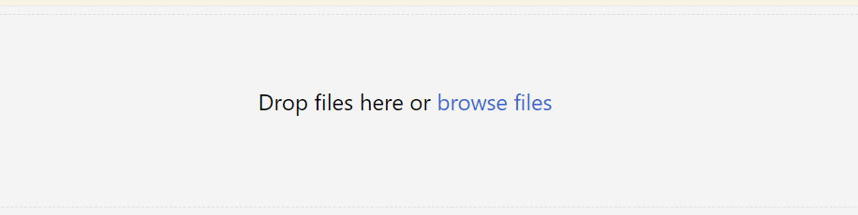
Once a file has been uploaded, you can tick whether it is the accepted version or the publisher’s published version. These files must have availability set to “Open file” for the requirements for open access to be fulfilled. If you register an embargo date, the file will not be openly available until that date.
Please also upload a publishing agreement, to make it easier to later check that the registration in NVA is in accordance with the legal requirements of the agreement. A publishing agreement can be the contract you signed with the publisher, e-mail correspondence with the editor, or an internal note from your institution, that specifies which article version you’re allowed to make openly available, under which licence and if there is an embargo date. These files should have accessibility set to “internal file”. They will then only be visible to people who can edit the registration.
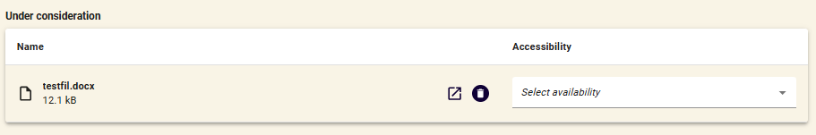

License/Terms of use
In addition to making the article publicly available, you must inform potential readers about how they may reuse the article in their own work. You do this by registering a license on the file, or files, you uploaded.
When you click on "Terms of use", you will get a list of all Creative Commons licenses, and a license type called "Publisher's terms". It is mandatory to set a license type on uploaded versions of the article.
Select the license type that is specified in the agreement with the publisher or the one that is in line with your institution's Rights retention policy (RRS). If your institution has an RRS, the licence for the accepted version will be automatically set to CC-BY. For a description of different license types, see openscience.no.
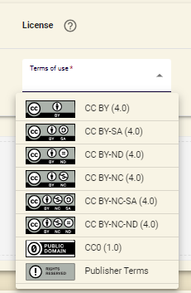

Embargo
If the article is subject to embargo, click on the down pointing arrow, and type or select the embargo date.
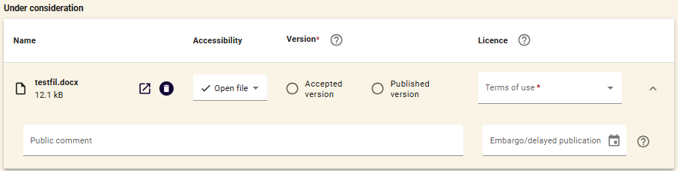

If your institution does not have an RRS, but you must follow Plan S
Government agencies, and certain funders, demand that research they have funded are published open access in accordance with Plan S. If your institution doesn’t have an RRS, you are given a check box in NVA when you upload the accepted version of the article, where you can indicate that the publication meets the requirements. You find the check box in the same place as the embargo date.
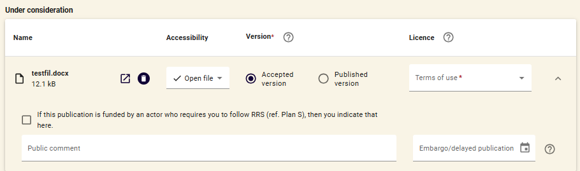

Publish metadata
Once all files have been uploaded with a license, click on the button "Save and view" to preview the registered information. You will see a blue box that says, "The result is not published".
To publish the registered description of the article, click on the button that says “Publish registration” under the menu titled "Publication".
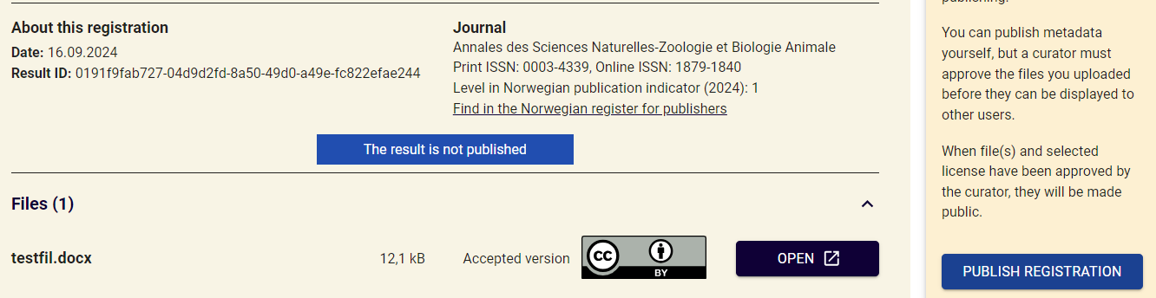
If a curator has been assigned the responsibility of making sure the uploaded file, license, and embargo date are in accordance with legal restrictions, they will automatically receive a message when you click on "Publish registration". Once they have reviewed and confirmed that everything is correct, files and licences will also be made available.
Note that you do not need to assign a license to an uploaded file to publish metadata, but you must mark the accessibility of the registration. If you do not do this, the registration will be saved as a draft. To complete the registration later, go to "My Page" and Result registrations. You will then see a list of all your registered drafts.

Help with registration
On all registration pages there is a button at the very bottom called "Get help from a curator". If you need help with a registration, click on the button to send a message to your local curator (responsible for user support). You find their response under "Dialogue" on "My Page".
